**Biorefrigerator Security System**

Biomedical Engineering Senior Design

Dr. Aijun Wang

Progress Report 4

Spring 2024

Team 1

Brayden Chipman -

Miguel Cruz -

Ashwin Halepet -

Vance Padilla -

**Table of Contents**

**Executive Summary 1**

Problem 1

Objective 2

Design Solution 2

Assessment of Design Goals 2

Value Impact 2

Future Work and Improvements 2

# Executive Summary

Figure 1: Introductory Figure for the Design

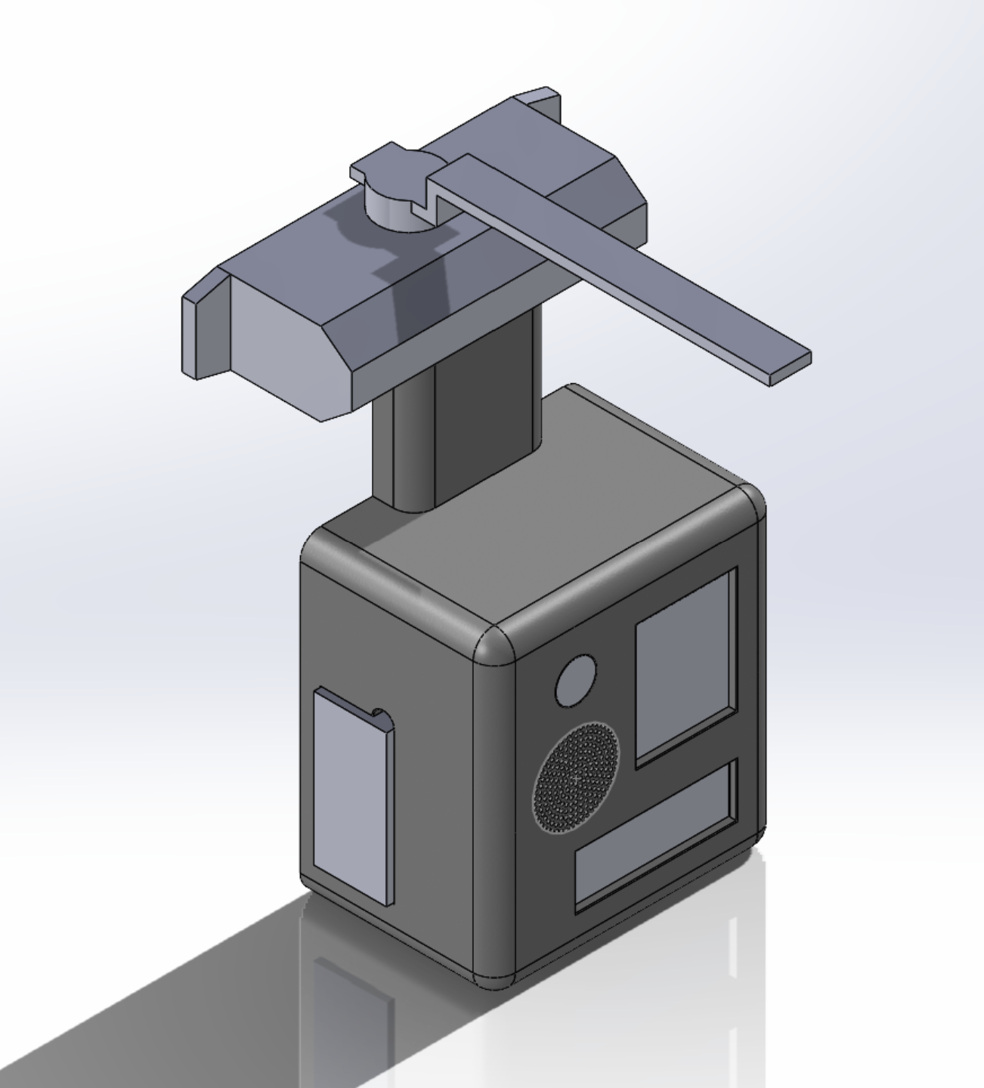

We are 3rd and 4th year students enrolled in UC Davis’ BIM 110, “Biomedical Engineering Senior Design”. We have been assigned to work on a project proposed to us by Dr. Aijun Wang and PhD candidate Yongheng Wang. Over the last three quarters, we have developed the Biorefrigerator Security System depicted above. This device’s function is to prevent the loss of biological samples that are stored in a controlled laboratory environment (CLE), such as a -20 C or -40 C freezer, thus preventing the associated monetary loss that results from the loss of materials. This device works by using an automated, hydraulic door closer to prevent the CLE door from remaining open. Furthermore, this device also has a PIN pad to ensure that only members of the lab who are using the CLE can access the samples and to provide a record of the last user. Additionally, the device has an alarm system to alert users that either unauthorized access occurred, or if the door is propped open.

## **Problem**

In laboratories, controlled laboratory environments (CLE) such as refrigerators and freezers are critical for preserving the integrity of biological samples, reagents, and other temperature-sensitive materials. These CLEs store high-value and possibly irreplaceable items that are essential for ongoing research and diagnostic activities. However, a recurring issue is that older CLEs are sometimes left open, leading to significant financial loss for laboratories. This is due to older CLE models usually lacking safety measures such as built in alarms and temperature monitoring systems. Laboratory materials, worth multiple thousands of US dollars or more and possibly years of research, are stored in CLEs worldwide. Freezer failures have cost laboratories millions of US Dollars over the past decade. There have been at least five major laboratory freezer failures since 2012 [1]. One example of this is when stem cells from cancer treated children were lost from a hospital freezer at Children’s Hospital Los Angeles in 2019 due to a failure of freezer temperature sensors [2]. Such an event caused major disruptions to future care possibilities and to the patients and their families.

Current methods of ensuring that a frequently accessed CLE remains closed are limited by the need for human input. Users typically interact with the CLE by opening or closing the doors manually. Requiring the use of human input introduces the possibility of human error. Some newer models of CLE’s have methods to signal that they are left open such as audible alarms that older CLE models may not have. The most common error of human input in CLE’s is accidentally leaving them open. Exposure to room-temperature should be minimized and have been proven to negatively affect biological material, such as proteins, over time. For example, even short periods of thawing and refreezing can lead to mild denaturing and minor loss of proteins. Ten cycles of thawing and refreezing already show at least over 5% loss of many types of proteins [3]. As for what this loss might look like financially, the private sector cost per dose for the Pfizer COVID-19 vaccine is $115 [4]. A single shipment of the Pfizer vaccine includes 4875 doses, spread across 5 trays equaling a total cost of $560,625 [5]. A loss of 5% of this shipment will cost the facility approximately $28,000. Ideally, it would be best to prevent this situation from occurring as the loss of materials can lead to time and monetary loss.

## **Objective**

The objective of the Biorefrigerator Security System is to develop a device that minimizes the risk to sample integrity due to prolonged exposure to ambient conditions. The device is designed to be power efficient, affordable, easy to install, and easy to use. Primary intended use cases are CLEs such as chemical and biological laboratory refrigerators, as well as incubators.

## Design Solution

Our design solution is a device that enables automatic closure of CLE doors without the need for laboratory workers to intervene. The main housing of the device will be installed on the door of the CLE, and the arm will be attached to the top of the CLE. A hook-style lock system is attached atop the closer housing in order to resist opening the CLE when in the locked state. The main housing of the device will contain a PIN pad that users will use to lock and unlock the CLE. The door status is considered “closed” when a limit switch that is placed in the door is pressed. Once not pressed, the door status will read as “open”. The LED and speaker alarms are set to trigger when the door status changes to “open” when the locked status is “locked” or when the door is open for over two minutes. The device will be powered by disposable or rechargeable 9V batteries (as supplied by the end user). Figure 1 illustrates the device when fully assembled.

We decided to proceed with PLA instead of metal since thick PLA is sturdy enough for our use, and it is lighter and easier to produce, as well as being a way to reduce waste since there is no laser cutting and welding involved.

## 

## Assessment of Design Goals

In order to confirm that the Biorefrigerator Security System meets the established product specification, verification tests were conducted to ensure functionality at the individual component, subsystem and full assembly levels.

Table 1: Component Verification Results

| **Component** | **Simplified Test Method** | **Data** | **Data Analysis Method** | **Result Analysis Method** | **Result Analysis** | **Pass/No Pass** |
| --- | --- | --- | --- | --- | --- | --- |
| Battery | Measure battery voltage | 9.68, 9.69, 9.68 | average and standard deviation | Mean ≥ 9 V | Standard Dev. ≤ 0.225 V | Mean: 9.683 V Standard Dev. 0.005 V | PASS |
| Microcontroller | "Hello World" Arduino Protocol | Functional | Binary: functional or nonfunctional | n/a | n/a | PASS |
| Red and Green LED | Input voltage to green and red LED pins | Functional | Binary: functional or nonfunctional | n/a | n/a | PASS |
| Speaker | release alarm sound of 1000 to check for audibility at conversational volume | Functional | Binary: functional or nonfunctional | n/a | n/a | PASS |
| Limit Switch | Attach limit switch to microcontroller. Change in input reading is expected when the lever is pressed | Functional | Binary: functional or nonfunctional | n/a | n/a | PASS |
| LCD Screen | Display the "Hello World" Arduino Protocol | Functional | Binary: functional or nonfunctional | n/a | n/a | PASS |
| Pressurized Door Closer | Pull back the arm of the Door Closer and examine if it returns to the original postion when released | Functional | Binary: functional or nonfunctional | n/a | n/a | PASS |

Table 2: Subsystem Verification Results

| **Subsystem** | **Simplified Test Method** | **Result Analysis Method** | **Result Analysis** | **Pass/No Pass** |
| --- | --- | --- | --- | --- |
| Alarm System 1 | Press down the lever on the limit switch then release for 2 seconds. Both alarms should trigger. | Binary: functional or nonfunctional | n/a | PASS |
| Alarm System 2 | Input the PIN Code "77777777". Both alarms should trigger | Binary: functional or nonfunctional | n/a | PASS |
| PIN Pad and Lock 1 | Input the PIN Code "1234567". Servo arm should rotate 90 degrees clockwise in the locked state and 90 degrees counterclockwise in the open state | Binary: functional or nonfunctional | n/a | PASS |

Table 3: Validation Results

| **Component** | **Simplified Test Method** | **Scale (If Needed)** | **Result Analysis Method** | **Result Analysis** | **Pass/No Pass** |
| --- | --- | --- | --- | --- | --- |
| Final Cost | Sum of used parts in USD | n/a | Sum < 200 is considered a "pass" |  |  |
| Final Weight | Weigh final assembly with a scale in pounds | n/a | Final Weight =< 7 pounds is considered a "pass" |  |  |
| Battery Life | Measure average hourly voltage usage and calculate approximate battery life | n/a | Battery life >= 6 months |  |  |
| Ease of Use | Qualitative: Users given a survey to rate understanding of device usage | fully intuitive --> some guidance needed --> training required | Some guidance needed is considered a "pass" |  |  |
| Ease of Handling | Qualitative: Users will be given a survey to rate if the device makes the CLE more difficult to operate or not | no difference--> slightly more difficult--> moderately more difficult--> much more difficult | Slightly more difficult to operate is considered a " pass" |  |  |
| Security | Measure force required to make the hook lock detach from the servo | n/a | Binary: functional or nonfunctional |  |  |
| Accountability | Future development: Give users unique PIN codes and store the most recently used | n/a | Binary: functional or nonfunctional |  |  |

| **Metrics** | **Units** | **Corresponding User Needs** | **Range** | **Target Value** | **Direction of Improvement** |
| --- | --- | --- | --- | --- | --- |
| Price | US Dollar | Affordability | $14-$984 | $300 | To be minimized |
| Battery Life | Months | Power Delivery | 1- | 6 | To be maximized |
| Passive Operation | Binary | Ease of Handling | Fully Active to Fully Passive | Mostly Passive | To be maximized |
| Number of Components | Numerical | Ease of Manufacturing | 10-100 | 20 | To be minimized |
| Established Technology | Binary | Practicality | Yes or No | Yes | N/A |
| Weight | Pounds | User Friendliness | 1 to 8 | 7 | To be minimized |

## Value Impact

The Biorefrigerator Security System design improves on existing CLE locking systems by combining the security measures of alarms and identifying users with an automatic closing system. These security measures not only prevent the lock from opening, but they are also able to alert nearby users of the CLE doors being left open. The device design uses preventative as well as corrective measures to minimize the monetary costs from loss of biological materials stored in CLEs. As mentioned in the Problem section, losing even a small percentage of laboratory materials can lead to thousands of dollars of loss.

There is not a widespread solution for a CLE locking system that is reasonably priced and easily accessible. This device will help reduce the risk of CLE’s opening spontaneously or being left open by the user, which can impact the laboratory samples inside the CLE, by ensuring that the CLE door is closed to protect the laboratory samples. There are existing solutions for CLE locks, but they are not widespread and they are expensive. Table 3 compares our design to some alternatives on the market as well as combinations of devices to reach similar functionality. The customer can benefit from having a secure system to protect their CLE in the lab while also not being too pricey. The combination of an alarm, PIN pad, and lock system means that the device will have advantages with different security features all in one device. The device will have a way to notify the user about an open CLE using an alarm, a way to unlock the CLE and to shut off the alarm using a PIN pad, and a way to keep the CLE closed using a lock system with a pressurized door closer. The combination of both an alarm and a PIN pad system can benefit laboratory users since there is a way to secure the CLE as a preventative measure to ensure the CLE stays shut while ensuring that when the foolproof measure fails, laboratory users can be easily notified by a visible and audible alarm, which in turn will prevent disasters such as losing cells and data. The amount of time saved from having an audible and visual alarm is immense as an alarm system can quickly notify nearby people a CLE is not closed all the way, rather than someone finding out eventually without realizing that the CLE is open when it should not be.

Some of the competitors to the Biorefrigerator Security System are listed below. The BEOL Biological Refrigerator Smart Lock has features such as remote lock authorization and electronic notifications that our design does not, however this comes at a much higher cost per unit of nearly $1000 per lock. The Monnit Remote Temperature Monitoring system allows users to view a graph of CLE temperature over time and also includes electronic notifications that can be configured by the user. This system requires not only a higher initial cost of $369, but also a $45 per year subscription to unlock automated reporting and multiple user authorization. The final competitor would be a combination of devices that combine to reach similar functionality to the Biorefrigerator Security System. This combination comes out to a cheaper price of $54.22 but lacks any way to authorize or verify users which can lead to a lack of accountability.

Table 3: Benchmarking of the Biorefrigerator Security System

| Alternative Number | Device | Door Security | Status Sensor | Automatic Door Closing | Alarm | User Log | Price / One CLE | Vendor |
| --- | --- | --- | --- | --- | --- | --- | --- | --- |
| 0 | Biorefrigerator Security System | **X** | **X** | **X** | **X** | **X** | $172 | n/a |
| 1 | BEOL Biological Refrigerator Smart Lock | **X** | **X** |  | **X** | **X** | $984 | BEOL |
| 2 | [Monnit Remote Temperature Monitoring System](https://www.monnit.com/temperature-monitoring/select-products/) |  | **X** |  | **X** |  | $369 + $45/yr | Monnit |
| 3 | [YEYA Refrigerator Lock](https://www.amazon.com/Refrigerator-Cabinet-Adhesive-Yeya-Standard/dp/B096QSGRG3/ref=sr_1_1?crid=1QBRBI64C3KJM&keywords=fridge+lock+combination&qid=1697565725&sprefix=fridge+lock+combination%2Caps%2C158&sr=8-1) | **X** |  |  |  |  | $6.25 | Amazon |
| 3 | [Freezer Door Alarm](https://www.amazon.com/Freezer-Window-Reminder-Office-School/dp/B0BX9FZ6CB/ref=sr_1_6?crid=M93LOUH7QYZR&dib=eyJ2IjoiMSJ9.alN86vbUQqt6m7kTLhMMxIvmq2IYH562DVMWjLor9SEEm4Ub8WaHZM5KUthAhQhbwQSjZMYpjDAsACTx7jf1IdIcCRb_omqTcttDZYStzDg7EDcI-sO4FyhfPoFtxVf9XxqsJ-h1JHxoDO0S6wn-eWrcW0LllVz-w4BcZRxMfXlP5NAh1Ox4E8NW89I430ujfB1C20AE9815P_OpzlKTVrf3YlYsRyjAp62B5QRLZXhPxij58kHf4GXaaBMZAnjXllsuLxSxp4tK07vRBhwkG-qGDoO9wlIJymcHKY7XMjQ.rGjz54jLmFpj370umoFvUX7vzyathf8Plclf3tJFbI8&dib_tag=se&keywords=Open%2Bclose%2Bsensor&qid=1715273470&sprefix=open%2Bclose%2Bsensor%2Caps%2C160&sr=8-6&th=1) |  | **X** |  | **X** |  | $16.99 | Amazon |
| 3 | [BRINKS Commercial - Light Duty Residential Door Closer](https://www.amazon.com/BRINKS-Commercial-Residential-180-Degree-Adjustable/dp/B09C18PHBN/ref=sr_1_15_sspa?crid=2MBJMPPYGD7RM&dib=eyJ2IjoiMSJ9.0ezEOHe8QyIM-ea4AqCBhpgWbxGgDqMiN4k1uuVyqsyfMqRmC326rEIwVSwUlElDk8yB3cU2F-RVFyZxDoL3V4OTFSTMHg14a9AL_xy1WCIhDb1-yhFH4mSJPSZVuov_LwRfcjELHC5_yxl_xPMI6eNpfRu7Wqw9WBX5splkUuXANO4jEmHeRf-GelKm2ySZhWkBU8NTaVEvY-yfMGa-MMFuoMo2CZvcXxa_13wEzyysK53_sidqlRKGAlClo0kxdZpF6K6nz9qzt2CkxNYul860r-_qoeP1I4_ZJPtTDhU.yxAaWdu6bziTjkFYULao25qZJQ5Oqq-0aepeg7VYNKU&dib_tag=se&keywords=automatic%2Bdoor%2Bcloser&qid=1715273632&s=hi&sprefix=automatioc%2Bdoor%2Bclos%2Ctools%2C196&sr=1-15-spons&sp_csd=d2lkZ2V0TmFtZT1zcF9tdGY&th=1) |  |  | **X** |  |  | $30.98 | Amazon |
| 3 | Total | **X** | **X** | **X** | **X** |  | $54.22 |  |

## Future Work and Improvements

To advance the project further and improve on the current design, we have ideas on how we can do so. There exist two main categories that we could improve in future revisions. These are the casing and remote capabilities. The casing itself can be changed to include further support for the circuitry components by adding standoffs and internal brackets. A custom-sized circuit board with Arduino capabilities would be another improvement as this would reduce wiring inside the case as components could be directly soldered onto a singular board. We can also attempt to find a way to modify the sizing of the lock so that it can connect and fit in all types of CLEs, no matter the size. Another possible improvement is to change the way the device stores user information so that using the device automatically creates an audit log onto a spreadsheet. In order to automatically log information onto a spreadsheet, we can incorporate remote connectivity with WiFi and/or Bluetooth onto the code. Additionally, we can utilize these technologies to remotely unlock and lock the CLE.